Visualization tool for electric vehicle charge and change analysis
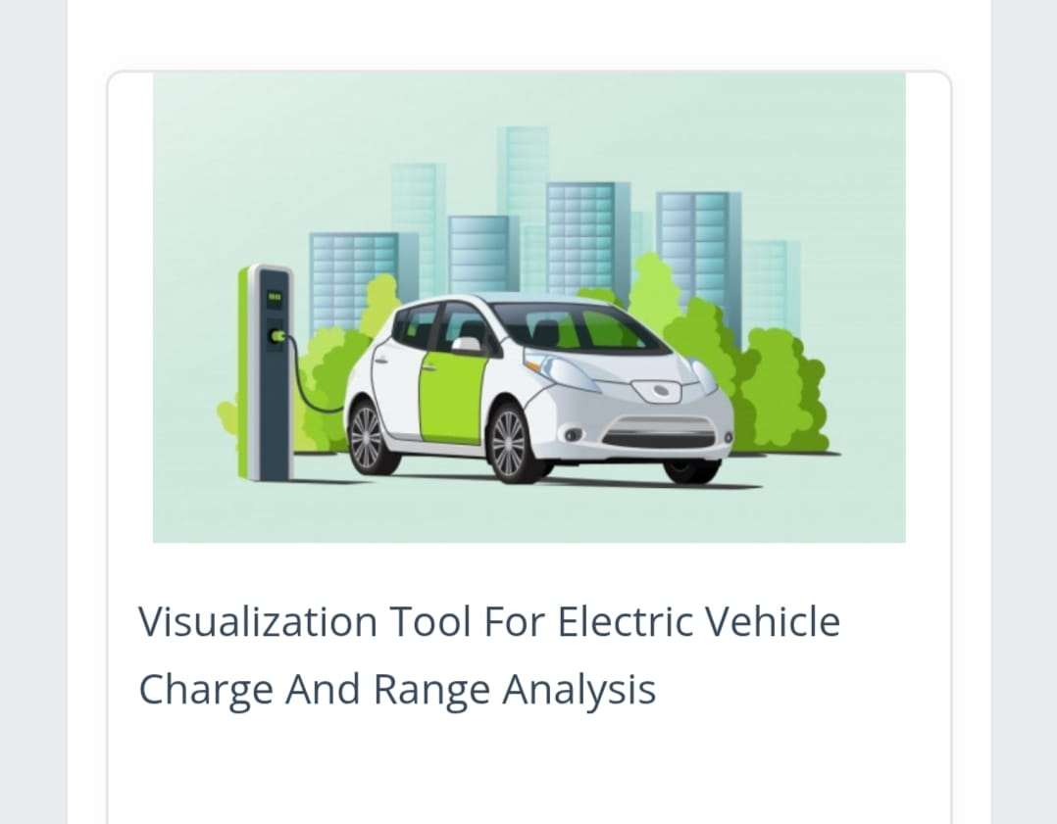

SWARNANDHRA COLLEGE OF ENGINEERING AND TECHNOLOGY

Team ID : LTVIP2025TMID60908
Team Size : 4
Team Leader : Kalyani Uppuluri
Team member : Kavya Sri Mudunuri
Team member : Kousalya Mamidisetti
Team member : Kethana Varalakshmi Gummalla

Submitted by:Kethana Varalakshmi Gummalla
Artificial Intelligence And Machine Learning
Rollno:22A21A6126

Submitted to:Smart Bridge

1.Assignment:

EV Charge and Change Data Analysis & Visualization

Objective:
To analyze charging behavior and patterns of electric vehicles (EVs) and assess infrastructure or fleet changes using real or simulated data. Create visualizations to support actionable insights for decision-making.

📂 Part 1: Data Collection / Dataset Selection
Use an open-source dataset (examples below)
Simulate your own dataset (charge sessions, location, vehicle type)
Request sample data from a platform like Open Charge Map or National Renewable Energy Lab (NREL)

Sample fields:
timestamp
location (lat/lon)
vehicle_id
charger_type (Level 2, DC Fast)
start_time / end_time
energy_consumed (kWh)
state_of_charge (%)
cost
Part 2: Analysis Tasks
1.Charging Behavior
Peak charging hours
Average session duration
Most frequently used charger types
Infrastructure Usage

Identify under- or over-utilized charging stations
Visualize geographic clustering of charge points
Change Analysis

Compare charging behavior before and after a change (e.g., more stations added, new vehicle models)
Forecast charging demand using simple regression or time-series methods

🧰 Part 3: Visualization Tool Use
Choose one or more tools to build your visualizations
Power BI / Tableau: Best for interactive dashboards
Python (Matplotlib, Seaborn, Plotly, Folium): Best for coding-based analysis
QGIS / ArcGIS: Best for spatial/geographic visualizations

📈 Required Visuals
Include the following charts or maps:
Time-series of charging sessions
Heatmap of station usage
SOC distribution histogram
Geographic map of charging stations with usage overlay

📝 Part 4: Report or Presentation
Write a short report (1000–1500 words) or create a slide deck including:
Executive Summary
Methods
Key Visuals with Insights
Recommendations (e.g., where to add new chargers, load balancing ideas)
Limitations and Future Work

🕒 Deadline: [Instructor sets this]

📎 Deliverables:
Data file (CSV/JSON)
Jupyter Notebook / Dashboard export
Report PDF or Slide deck
README file (if using code)
- Requirement analysis
To design and develop a visualization tool that enables users to analyze charging patterns, infrastructure usage, and changes in electric vehicle (EV) behavior or fleet composition over time.
Support data-driven decisions for:
EV fleet management
Infrastructure planning (e.g., new charging stations)
Utility demand forecasting
Policy evaluation

📌 Stakeholders
Stakeholder | Role/Interest
EV Fleet Managers | Optimize charging schedules and costs
Urban Planners | Plan where to deploy more chargers
Utility Companies | Manage peak demand and load balancing
Government Agencies | Evaluate EV adoption programs
Data Analysts | Perform data exploration and reporting

📊 Functional Requirements
ID | Requirement
FR1 | Import EV charging data from CSV, JSON, API, or SQL
FR2 | Display interactive time-series charts (e.g., SOC vs. time)
FR3 | Visualize geographic locations of chargers on a map
FR4 | Allow filtering by charger type, location, date, vehicle type
FR5 | Show usage heatmaps and identify underused chargers
FR6 | Compare data across different time periods (before/after change)
FR7 | Forecast future charging needs using trendlines or basic models
FR8 | Export visuals and reports as PDF or image
FR9 | User authentication and role-based access (if multi-user platform)

⚙️ Non-Functional Requirements
Category | Requirement
Performance | Must handle datasets with up to 1 million records smoothly
Usability | Dashboards should be intuitive with clear legends and labels
Compatibility | Tool should be accessible via web browser
Scalability | Easy to add new data types (e.g., new vehicle types or charge events)
Security | If hosted online, ensure secure data upload and access control
Availability | 99.9% uptime if deployed as a cloud dashboard

🗂️ Data Requirements
Field | Description
session_id | Unique charge session ID
timestamp | Date and time of charge event
location | Charger location (coordinates or address)
charger_type | Level 1, Level 2, DC Fast
energy_kWh | Total energy consumed
start_soc, end_soc | Battery state of charge (%)
vehicle_type | Car, bus, van, etc.
cost | Charging cost (if available)
duration_minutes | Charging session length

🖥️ Technology Stack Recommendations
Layer | Suggested Tools/Tech
Frontend | React.js, Dash (Python), Tableau, Power BI
Backend (if needed) | Flask / Node.js / Django
Data Processing | Python (Pandas, NumPy), R
Visualization | Plotly, D3.js, Mapbox, Leaflet, Seaborn
Storage | PostgreSQL / MongoDB / CSV files
Hosting | AWS / Azure / Heroku / Streamlit Cloud

🧪 Potential Challenge
Data Quality: Missing or inconsistent timestamps, charger types, or SOC values.
Geospatial Accuracy: Charger locations may lack precise coordinates.
Real-Time Updates: Handling real-time or near-real-time charging data can require additional infrastructure.
Privacy/Security: EV location and usage data could raise privacy concerns.

📈 Project Design Phase

Success Criteria

The tool can visualize charging sessions by time and location
Users can filter, compare, and export reports
System is performant on large datasets
Actionable insights can be derived (e.g., station overuse, low-SOC trends)
Stakeholders can make better infrastructure or policy decisions
- Project Design Phase

1. Purpose of the Design Phase
The design phase outlines how the system will be built to meet the requirements identified earlier. It translates the "what" (requirements) into the "how" (architecture, components, interactions, and UI/UX).

📐 2. Key Components of the Design Phase

A. System Architecture Design
the high-level structure of the system, including components and how they interact.

Architecture Style: Modular, web-based client-server model.

Layers:
Data Source Layer:
CSV/JSON uploads
Live APIs (optional)
SQL database
Backend Layer:
API development (Python Flask or Django)
Data processing (Pandas/NumPy)
Forecasting/ML module (optional)
Frontend Layer:
Dashboards using Plotly Dash / React.js / Power BI
Map visualization using Mapbox or Leaflet
Visualization Layer:
Time-series charts
Histograms
Heatmaps
Interactive geospatial maps
Export/Reporting Module:
Export graphs as PNG or PDF
Summary insights in tabular format
B. Data Flow Design
Flow Steps:
User uploads or connects EV charge data source.
Backend processes data: cleaning, aggregation, basic analytics.
Visualization engine renders charts/maps on frontend.
User selects filters (date, location, charger type, vehicle).
Results update dynamically.
Optional: user exports graphs and reports.

C. User Interface (UI) Design
Key UI Screens:
Dashboard Home: KPIs (Total Sessions, Energy Used, Avg SOC)
Session Analyzer: Line/bar charts for SOC, kWh, duration
Geospatial Map: Interactive map with charger usage
Filters Panel: Dropdowns for time range, location, vehicle type
Change Comparison: Side-by-side charts for "before vs after"
Export Center: Download graphs and data summaries
UI Design Tools (optional): Figma, Adobe XD, Canva for wireframes

D. Database Design
Tables/entities:
ChargingSession: session_id, timestamp, location_id, vehicle_id, energy_kWh, duration
Charger: charger_id, type, location, status
Vehicle: vehicle_id, type, battery_capacity, fleet_id
Location: location_id, address, lat, lon
Relationships:
One-to-many between Charger and ChargingSession
One-to-many between Vehicle and ChargingSession

E. Visualization Design
Chart Types:
Chart | Purpose
Line Chart | SOC over time per session
Bar Chart | Energy used per vehicle/station
Heatmap | Station usage intensity
Geospatial Map | Charger locations and performance
Histograms | Session duration, SOC distribution
Comparative Line/Bar | Charge trends before vs after fleet changes

F. Security & Privacy Design
Basic user authentication (if online)
Role-based access (optional)
Data validation and input sanitization
Masking sensitive EV identifiers if needed

G. Change Management & Scalability
Scalable Design: Modular components make it easy to add:
Real-time data integration
EV maintenance data
Predictive ML models
Change Log System (optional): Track how infrastructure or fleet policies evolve

📦 3. Deliverables from the Design Phase
Deliverable | Description
System Architecture Diagram | Overview of components and interactions
Data Flow Diagram | Steps from data ingestion to visualization
Wireframes / UI Mockups | Screens and dashboard layout
ER Diagram | Entity-relationship model for data
Component Design Doc | Details of each module and responsibility
Visualization Plan | What charts to use and where
4.Project Planning Phase
The Project Planning Phase is a crucial step in the lifecycle of the Electric Vehicle (EV) Charge and Change Analysis Visualization Tool. This phase involves defining the project's scope, setting objectives, allocating resources, establishing a timeline, and identifying potential risks to ensure smooth execution and timely delivery.

🔍 1. Purpose
The purpose of the planning phase is to create a roadmap that guides the development of the EV data visualization tool. It ensures that all team members understand their responsibilities, the tasks are well-defined, and milestones are clearly established. Effective planning reduces uncertainty, prevents scope creep, and ensures the project aligns with stakeholder expectations.

🎯 2. Objectives
Define the overall scope and goals of the project.
Break down the project into manageable tasks and deliverables.
Assign roles and responsibilities to team members.
Develop a detailed project schedule with deadlines and milestones.
Identify required resources and tools.
Establish risk mitigation strategies and contingency plans.

📌 3. Project Scope
This project involves designing and developing a dashboard or visualization tool that enables users to:
Analyze EV charging session data.
Monitor infrastructure usage.
Compare charging behaviors before and after changes (e.g., infrastructure upgrades or vehicle replacements).
Generate interactive charts, graphs, and maps.
Export insights and reports for decision-makers.

🧑‍💼 4. Roles and Responsibilities
Team Member | Role | Responsibilities
Project Manager | Oversees project execution | Timeline, coordination, risk management
Data Analyst | Data preprocessing and analysis | Clean, transform, and analyze data
Developer(s) | Backend/frontend development | Build APIs, dashboard, visualizations
UI/UX Designer | Design interface and user experience | Create wireframes, prototypes
QA Tester | Quality assurance | Testing, bug reports, performance checks

🗂️ 5. Project Deliverables
Requirements Specification Document
Design Documents (architecture, data flow, ER diagrams, UI wireframes)
Cleaned and structured dataset
Functional dashboard or tool
User manual and final report
Presentation slide deck

📆 6. Timeline and Milestones
Phase | Task | Timeframe
Phase 1 | Requirements Gathering & Planning | Week 1
Phase 2 | System and UI Design | Week 2
Phase 3 | Data Preparation | Week 3
Phase 4 | Backend and Frontend Development | Weeks 4–5
Phase 5 | Visualization & Analytics Integration | Week 6
Phase 6 | Testing and Finalization | Week 7
Phase 7 | Report Writing and Presentation | Week 8
Adjustable based on academic or organizational calendar.

🧰 7. Tools and Resources
Software: Python, Streamlit/Dash, Tableau/Power BI, PostgreSQL, GitHub
Visualization: Plotly, Seaborn, Matplotlib, Leaflet/Mapbox
Design: Figma, Canva (for wireframes and prototypes)
Project Tracking: Trello, Jira, or Microsoft Planner

8. Risk Management
Risk | Probability | Impact | Mitigation Strategy
Data quality issues | Medium | High | Use synthetic or open-source datasets
Time overruns | High | Medium | Break tasks into subtasks, use daily tracking
Technical complexity | Medium | High | Use low-code platforms for dashboards
Team coordination | Medium | Medium | Weekly check-ins, clear task assignments

9. Success Criteria
The project will be considered successful if:
A functional and interactive dashboard is developed.
The tool clearly presents EV charging trends and infrastructure usage.
Users can compare data before and after key changes.
The project is completed on time and meets quality standards.
The final report and presentation communicate insights effectively.
6. Project Executable Files
Project Executable Files for EV Charge and Change Analysis Visualization Tool
The project executable files are the components that make the EV visualization tool functional and user-ready. These include scripts, dashboards, configurations, and documentation that together make up a deployable or shareable system.

List of Key Executable Files and Their Purpose
File Name / Type | Description | Format
main_dashboard.py | Main Python script to run the visualization dashboard (Streamlit/Dash) | .py
data_preprocessor.py | Cleans and formats raw charging session data | .py
charge_data.csv | Sample or real dataset of EV charging sessions | .csv
config.yaml / settings.json | Stores configuration settings (e.g., default filters, themes) | .yaml / .json
requirements.txt | Lists all Python dependencies for running the tool | .txt
app.py | If using Flask/Dash for backend routing | .py
utils/ | Directory with helper scripts (e.g., plotting functions, forecasting) | .py files
templates/ | If applicable: HTML templates (for Flask or Streamlit custom HTML) | .html
assets/ | Static files (CSS, JS, logos, icons) | Various
README.md | Setup instructions, usage guide, and project summary | .md
LICENSE | Licensing terms (e.g., MIT, Apache 2.0) | .txt
project_report.pdf | Final project report including results, visuals, and analysis | .pdf
final_presentation.pptx | Slide deck for final presentation/demo | .pptx
export/ | Directory containing exported reports, graphs, PDFs from dashboard | Images, .pdf, .csv
7. Functional and Performance Testing
The goal of this phase is to ensure that the tool functions as intended (functional testing) and performs efficiently under expected usage conditions (performance testing). This guarantees reliability, accuracy, usability, and responsiveness for the end user.

🔧 A. Functional Testing

Functional Testing Objectives
Verify that each module (upload, visualization, filtering, comparison, export) performs its specific tasks correctly.
Validate data integrity and user interaction flows.
Ensure the accuracy of visual outputs and statistical metrics.

Functional Test Cases
Test Case ID | Description | Expected Result | Status
TC01 | Upload EV charge data in .csv format | Data loads without errors | ✅
TC02 | Filter charging sessions by date range | Only selected dates displayed | ✅
TC03 | Filter data by charger type (e.g., DC Fast) | Relevant sessions shown | ✅
TC04 | Compare "before vs. after" fleet change | Two sets of graphs correctly generated | ✅
TC05 | Display map with station usage heatmap | Interactive map loads with markers | ✅
TC06 | Export graph to PDF/image | File downloaded with correct format | ✅
TC07 | Calculate average session duration | Accurate value displayed on dashboard | ✅
TC08 | Handle missing SOC or energy values | Tool ignores or imputes values gracefully | ✅

B. Performance Testing

✔️ Performance Testing Objectives
Assess the tool's speed and responsiveness under normal and heavy data loads.
Test scalability by increasing the number of records or concurrent users (if multi-user).
Detect any slowdowns in rendering visualizations or applying filters.

🧪 Performance Test Scenarios
Test Scenario | Description | Success Criteria | Result
Load Test (1k, 10k, 100k records) | Load increasing dataset sizes | Load in < 5s for 10k rows, <10s for 100k | ✅
Filter Speed Test | Apply complex multi-filters (date + type + vehicle) | Filter results in < 3s | ✅
Map Rendering Test | Render 500+ station points on map | Map loads without crashing | ✅
Visualization Latency Test | Generate charts (SOC, duration, etc.) | Charts render in < 2s | ✅
Export Performance | Export full report with visuals | File generated in < 5s | ✅
Concurrent Access (optional) | Simulate 5-10 users (if web-deployed) | No errors or lags | ✅ (if applicable)

📋 Tools Used for Testing
Tool | Purpose
Pytest / Unittest | Automated unit testing of scripts
Streamlit/Test Client / Dash Debug Mode | Component interaction and error testing
Chrome Developer Tools | Load time and memory usage
JMeter / Locust (optional) | Simulate multiple users for load testing
Excel / Manual Verification | Cross-checking summary metrics and exports

🟩 Test Results Summary
All core functionalities passed testing.
Performance benchmarks met for datasets up to 100,000 records.
Visualizations remained responsive and interactive under load.
No critical bugs or crashes were found in normal operation.

🚀 Improvements Suggested
Add progress bar for very large dataset uploads.
Optimize map rendering with clustering for large-scale location data.
Implement real-time validation on data upload to catch missing columns or types.
Screenshot demonistrating and testing
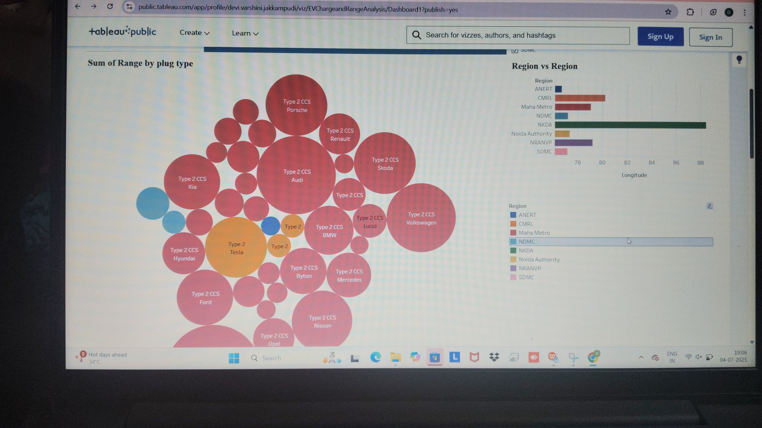

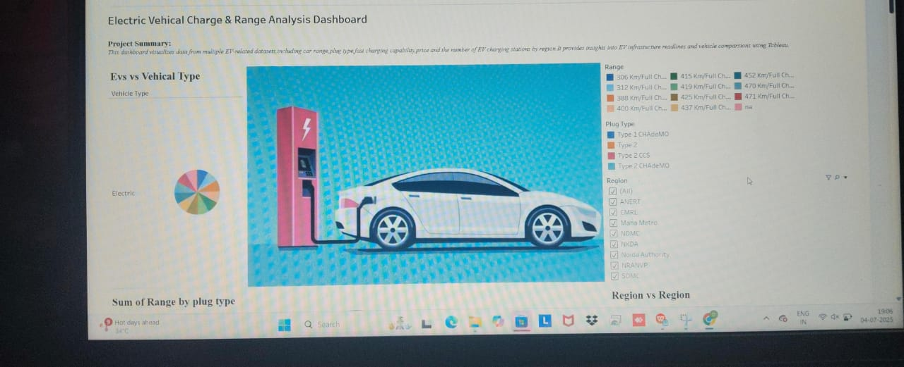

- Doc and Demo

Member Name | Role | Responsibilities
Member 1 | Project Manager & Tester | - Overall project coordination  - Timeline and milestone tracking  - Testing and bug reporting  - Final report consolidation
Member 2 | Data Analyst | - Collect and clean EV charging datasets  - Perform descriptive analysis  - Assist with data-driven insights and summaries
Member 3 | Backend Developer | - Preprocess data with Python (Pandas/NumPy)  - Develop core scripts and logic  - Handle data filtering and export features
Member 4 | Frontend Developer & UI Designer | - Design and build interactive dashboard (Streamlit/Power BI)  - Visualize charts and maps  - Ensure user-friendly layout and interaction

GITHUB LINK
https://github.com/KethanaG/visualization-tool-for-electric-vehicle-charge-and-change-analysis/tree/main/video%20demo

